* An update to your trello page
* a working component of your project
* documentation of your project that explains what your initial goal is, etc
* link to your project —— I don’t know how to submit the link so I just take some pictures.
* Appropriate comments in your work

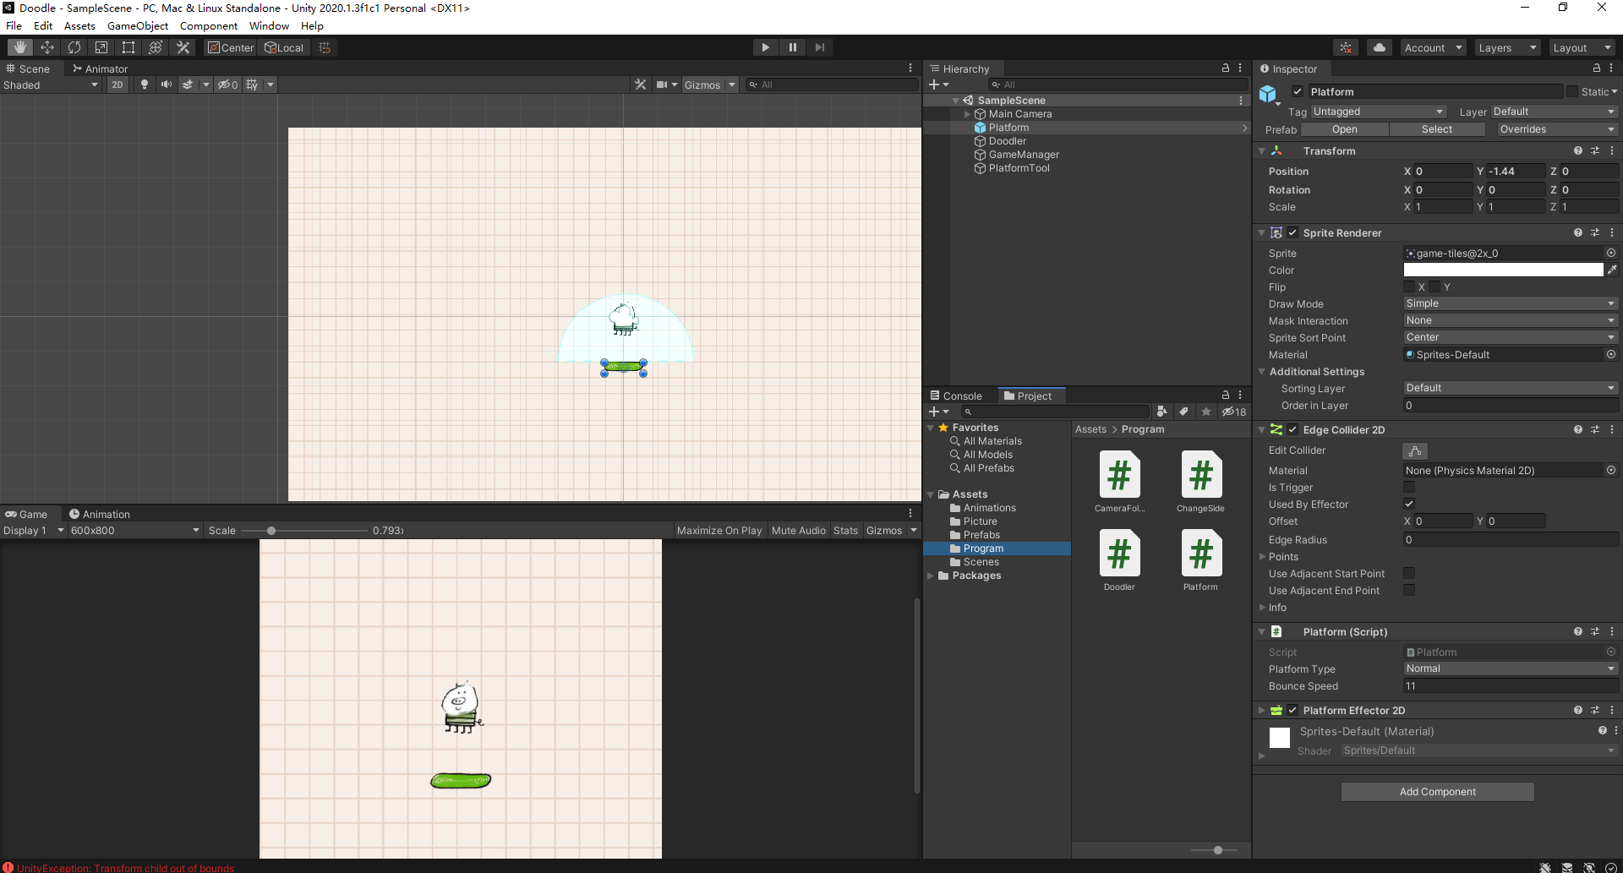

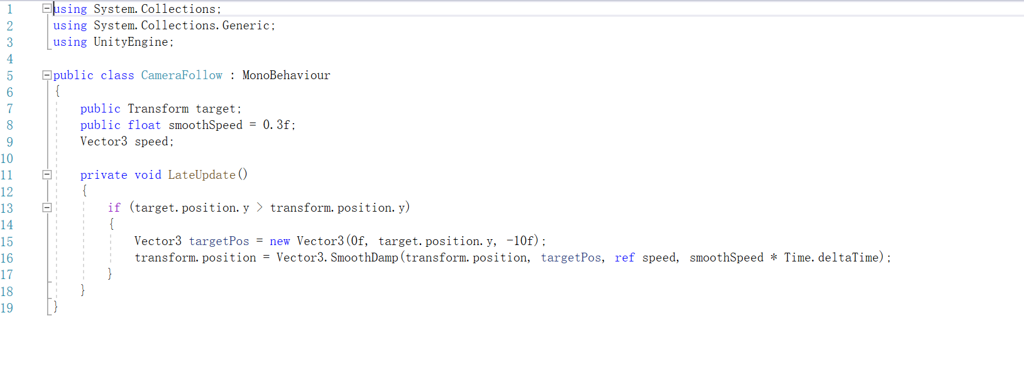

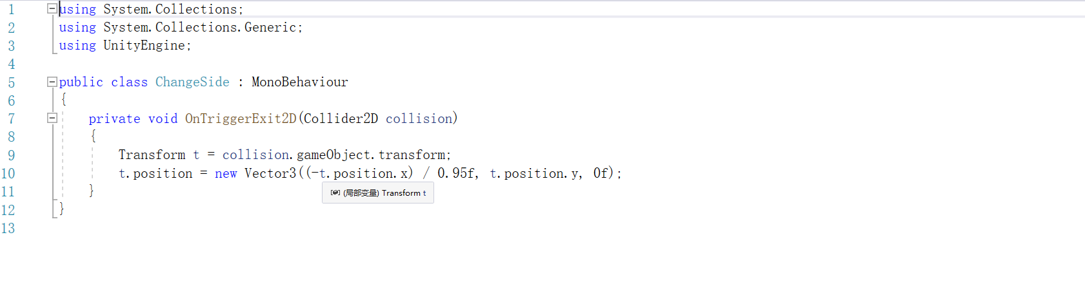

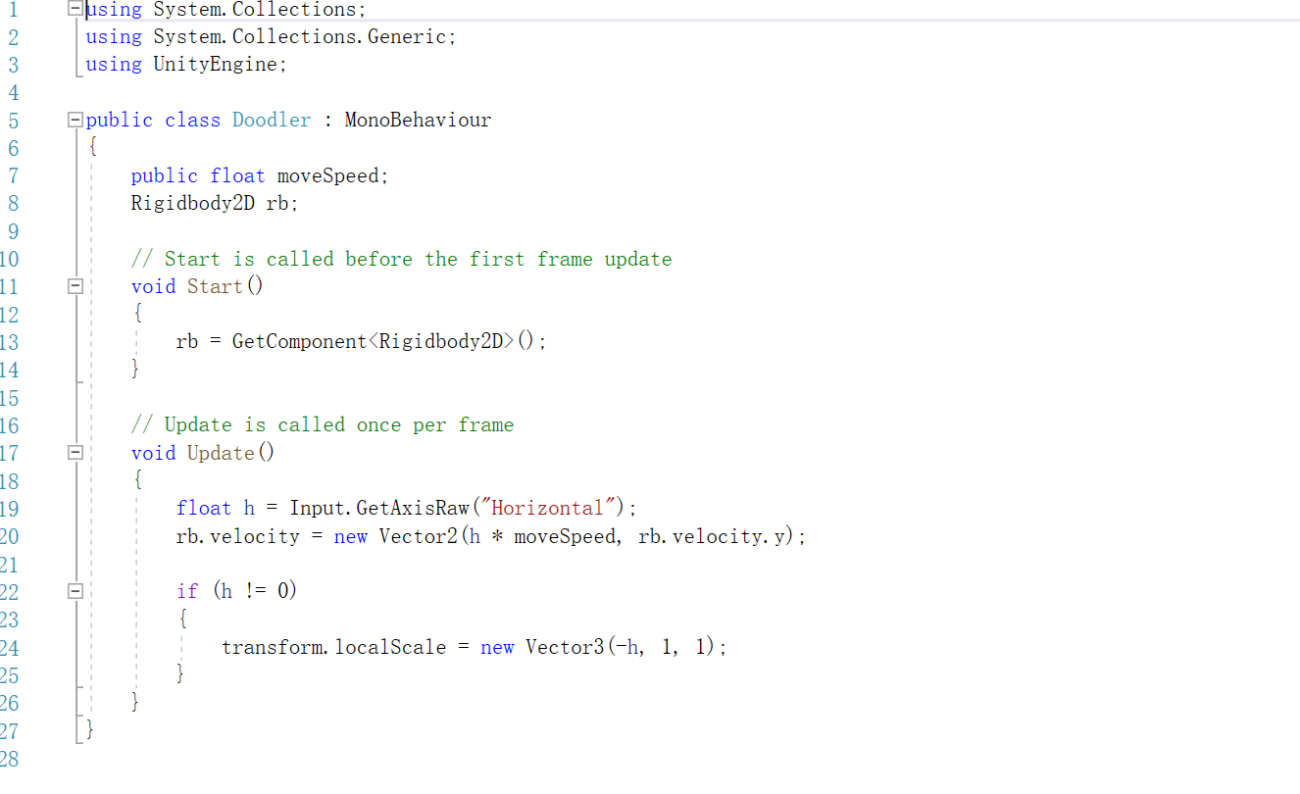

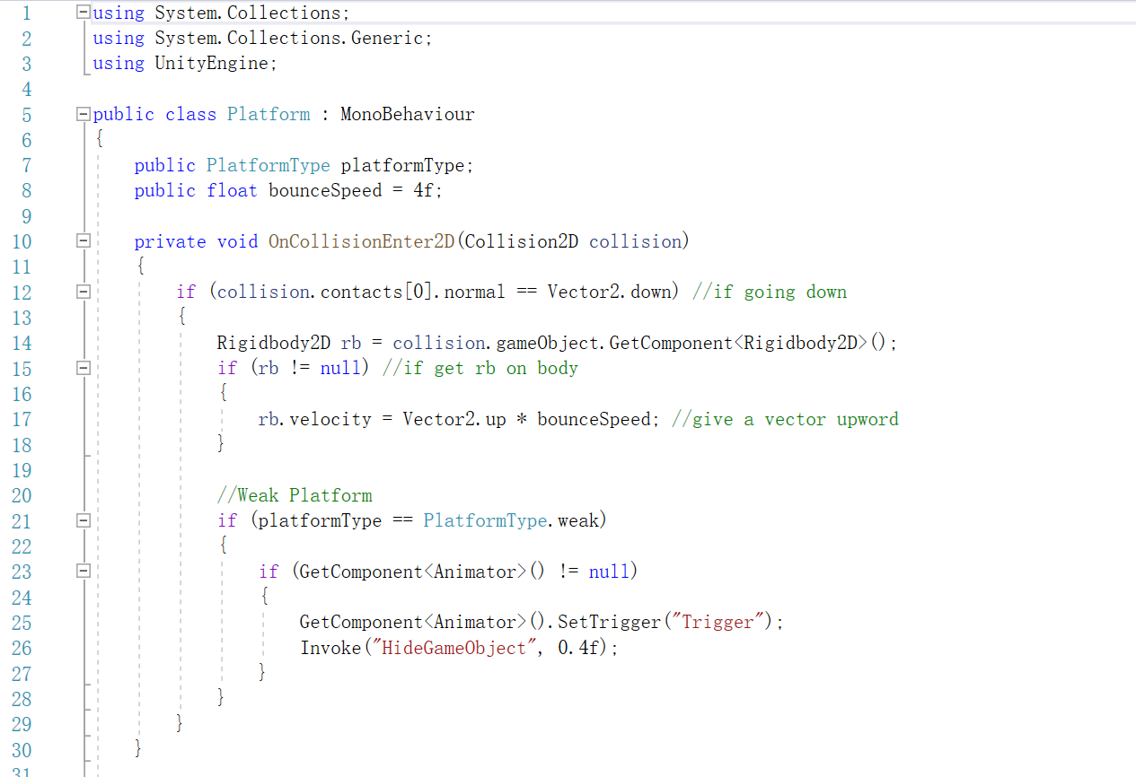

initial goal: My initial goal is that, let the pig doodler could jump on the platform, and the platform could form randomly, the background will follow the pig doodler moving. If the pig doodler step on the broke Platform once, then the Platform would destroy, which is not shows on the background any more… there is no Initial goal, because it's an accumulation game, players accumulate points by playing them over and over until they fall. Compare the scores of players. Compare the scores. The one with the highest score wins.

A working component of your project:

* Platform
  + Code
  + Platform effector 2D
  + Box collider 2D
* Doodler
  + Code
  + Box collider 2D
  + Rigid body 2D
* Game Manager
  + code
* Platform Tool
  + code
* picture(elements)
* background
* video making(edit)
* Animations
  + Code

Comments: So far now my project is working nicely, there is no big issue that I need to face of. I will add more elements to make the project perfect if I have more time in the future.

Report: what I’m done so far is:

1. Setting up the background, platform, doodler
2. When you press key “A”, “D” or “Left”, “Right”, the Doodler could moving left or right motion,(turning toward, face left or right)
3. The brown break platform, I use a video making when Doodler step on the brown step, the video will automatically playing to show the step is broken.
4. Shuttle back and forth.